**Web Design Final Project Report – Zoe Nicholson – S00153389**

**Git Hub:** <https://atr0pabelladonna.github.io/project/>

**Initial Proposed Sketch:**

**Checklist:**

|  |
| --- |
| **\*\*\* GitHub URL Progress upload of web site navigation and 3 pages – Week9** |
| **Project Report, Upload zipped folders all website files with report, (place college project on first page (index), no personal information to be included and public domain images and reference text and videos)** |
| **Minimum of 4 HTML Page Website** |
| **HTML5 standards and recommended page layout structure** (header,main,aside,article,section,footer) |
| **Include Meta data – description, keywords, title - Maximise SEO** |
| **Include font family for body of page** |
| **Appropriate use of External Style Sheet – Recommended CSS** |
| **Appropriate Example using Internal Styling on HTML page** (an example) |
| **Appropriate Example using of inline Styling** (an example) |
| **Home page content aligned to each other and visually attractive** |
| **Consistency of design on all pages above fold, aligned, use of fonts, colour etc.** |
| **Appropriate use of Headings (h1, h2, h3, h4)** |
| **Appropriate use of Colours, easy to read and complimentary colours** |
| **Include an article , section and aside sections** |
| **Clear, consistent and align content on page (reference all sources)** |
| **Include public domain images (**with at least on image floated with text**)** |
| **Use of background image** |
| **Include table of data/information** |
| **Include lists ordered and unordered (**different shaped bullet points**)** |
| **Include favicon and logo on your website** |
| **Include a contact form Display values entered in form and include red * beside required/mandatory input fields** |
| **Verify data collected on contact form, using get and data attached to URL** (Use the method get to display values entered on form will be appended to url and passed to server <form <action="http://foo.com" method="get">) |
| **Include google maps** |
| **Include columns using css that displays 2 or 3 columns on a page** |
| **Footer information include html entity Copyright© year and footer navigation menu** |
| **Include Internal Links and External Links** |
| **All pages should be up to 70% responsive** |
| **Include suitable video** |
| **Include Appropriate use of CSS Class and Id selectors** |
| **Appropriate use content layout using margins, paddings and borders (<br**> only used to split text on separate line eg address) |
| **Additional Features:** Gradient and Image as External Link |
| **W3C HTML & CSS Validator results (in report)** <https://validator.w3.org/nu/#file> |
| **Report include Proposal, Declaration of your own work , URL to Github, Rough Sketch of layout design, brief descriptions of the web site its pages and sources for information and Validator results** |
| **Website appearance, design and Content**  [**https://webdesignledger.com/10-signs-of-a-user-focused-design/**](https://webdesignledger.com/10-signs-of-a-user-focused-design/)  [**https://webdesignledger.com/20-dos-and-donts-of-effective-web-design/**](https://webdesignledger.com/20-dos-and-donts-of-effective-web-design/) |

**Description of each Page:**

**Index:**

The index page is where we see the Blue, Yellow and White theme for the first time.

The yellow car logo is float left in the header.

Below in the nav section we have the links to the other pages, they are reactive and change to yellow when moused over. Both the Nav and Footer sections have a yellow gradient in the background.

Below in the main section of the body, we have two sections left and right of each other, using a class to make them responsive and give them a yellow border.

In the left section, is a short paragraph about the company and its location. This is formatted using CSS to two columns with a 3 pixel divider down the center.

Below that, the company’s contact information is formatted using a table.

In the right-hand section labeled “Find Us” there is a picture of a recovery vehicle in the background, taken from <https://rs-recovery.com/new-service-van/> , with the google maps of the company embedded in the center.

The Footer is yellow gradient again, with image links to facebook and a dummy email for this example.

Below that is the copyright and the declaration that this is a college project.

**Index Validation:**

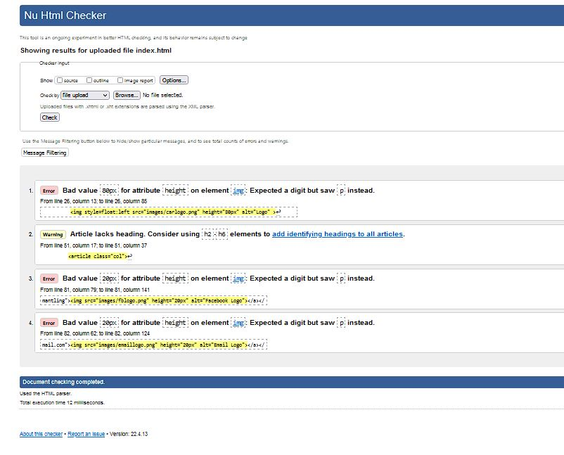

**Parts:**

The parts page features the same Header, Nav and Footer sections as the index page, these sections are the same throughout the website.

On this page there are responsive sections for each part for sale, using a class to center each box of content and give it a yellow border.

In each box contains a title, picture and list of features of the item for sale.

The H2 “Parts for Sale” has the ID “topparts” which allows us to click on the link at the bottom of the page “Go to Top” to bring us to the top of the page.

**Parts Validation:**

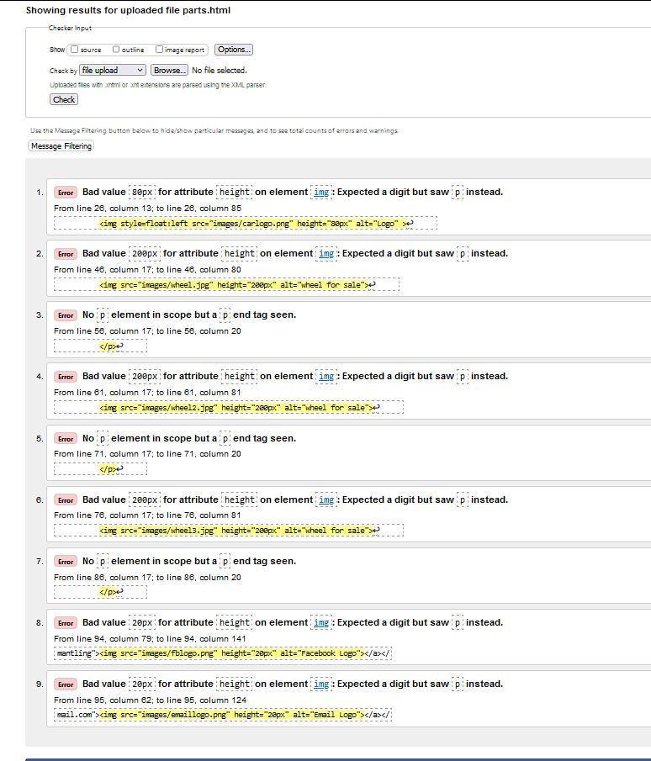

**Cars:**

The car page features the same blocks as the parts page, this time populated by the cars that are available for sale, along with pictures of the cars. The same themed Header, Nav and Footer is again featured.

**Cars Verification:**

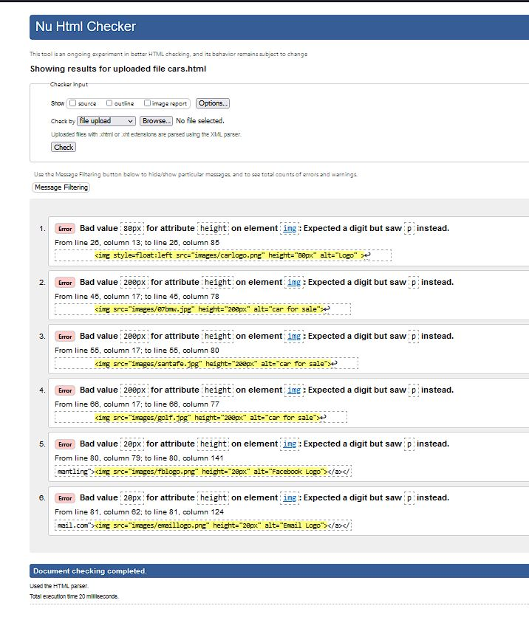

**Sell:**

The Sell page features a fillable form where the user can enter in the details of the part or car, they wish to sell to Kirby Car Dismantlers. I have the form on the “Get” method to allow you to see how this information is presented. The form features auto focus on the first name section of the form, as well as several required fields. At the bottom of the form there is both a reset and a submit button.

**Sell Validation:**

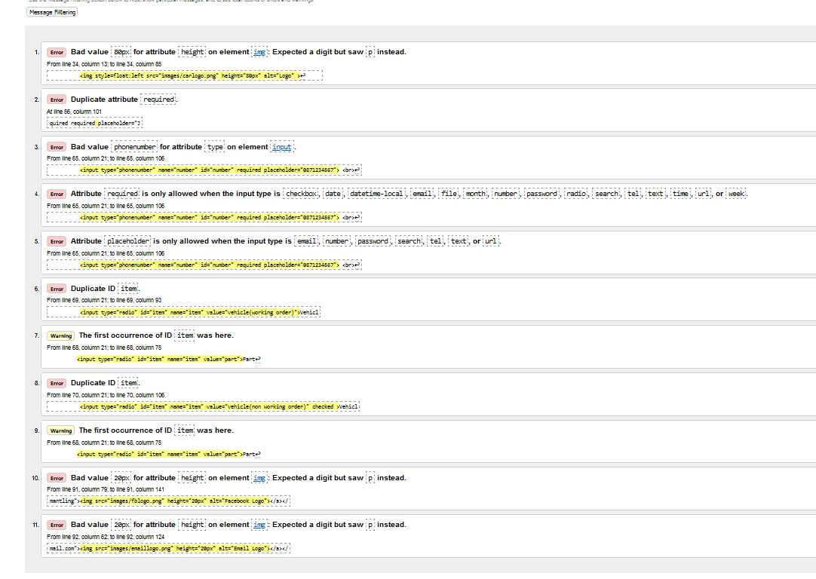

**Demo:**

The Demo page simply features a H2 “What happens in A Scrap Yard” and an Embedded YouTube video from Youtuber Henry Arnold. As always, the same Header, Nav and Footer is featured.

**Demo Validation:**

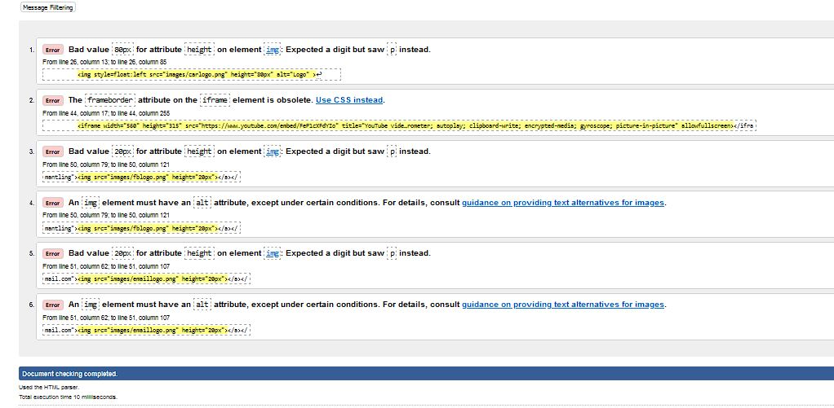

**Declaration**

I the undersigned declare that the project material, which I now submit, is my own work. This material or project has not previously been submitted for any other assignment. Any assistance received by way of borrowing from previous work, or the work of others has been cited and acknowledged within the work. I make this declaration in the knowledge that a breach of the rules pertaining to project submission may carry serious consequences. We are aware that the project will not be accepted unless this form has been handed in along with the project.

Website Topic: Kirby Car Dismantlers

Student name: Zoe Nicholson

Student number: S00153389

Date: 19/4/2022